Let’s share the care: A call to action to reduce the gender pay gap

|  |  |
| --- | --- |
|  | **Introduction** |
| Women’s disproportionate share of unpaid care and domestic work, lack of workplace flexibility and time out of the workforce are key contributors to the gender pay gap.  Diversity Council Australia’s (DCA) *Let’s Share the Care at Home and Work* report, timed to coincide with Mother’s Day on 12 May 2019, is a call to action to end the gender pay gap by enabling women and men in Australian families to ‘share the care’ more equitably.[1] | |

|  |  |
| --- | --- |
|  | **Australian women earn $239.80 less than men each week** |
| Closing gender pay gaps is one key pillar to achieving equality of economic opportunity for men and women. Yet World Economic Forum data suggests it will take over 200 years to achieve this.[2]  Australia’s full-time gender pay gap is 14.1 per cent, meaning women, on average, earn $239.80 per week less than men.[3] While it reached a record low in November 2018, it has remained between 14 per cent and 19 per cent for the past twenty years.[4]  More work is needed to eliminate gender pay gaps in Australia. Nearly nine in ten Australians (88 per cent) agree that inequality between men and women is still a problem in Australia,[5] while 76 per cent agree that steps should be taken to close the pay gap.[6] | |

|  |  |
| --- | --- |
|  | **One driver of pay gaps is the gendered impact of caring** |
| Women’s disproportionate share of unpaid care and domestic work, lack of workplace flexibility and time out of the workforce is a key contributor to the gender pay gap.[7]  Gendered divisions of unpaid care and work particularly emerge after the birth or adoption of a child. Before the arrival of a first child, on average, heterosexual partners spend comparable amounts of time on paid and unpaid work, but after a child, the proportion of care and housework undertaken by women increases considerably.[8]  The gendered nature of caring commonly kicks off with women being much more likely than men to access primary parental leave, and therefore to experience costly career interruptions. In 2016–17, just one in every twenty parents taking primary parental leave was a father.[9] 85 per cent of fathers take fewer than four weeks leave. Career interruptions accounted for 21 per cent of the 2014 gender pay gap.[10]  The gendered nature of caring persists well beyond the immediate arrival of a child. Even ten years after the birth or adoption of their first child, Australian women undertake 62 per cent of domestic work in a household.[11] In fact, married women with children do more housework than their male partners, even if both partners work full-time. [12]  Women also report carrying the household mental load – the burden of remembering, planning and organising. Nearly 70 per cent of mothers report frequently feeling chronically time pressured compared to 55 per cent of fathers.[13] | |
| Finally, the gendered nature of caring is not limited to parenting – twice as many women as men are the primary carer to a person with a disability, and of these women, 57 per cent are not in the labour force.[14]  The unequal distribution of unpaid care and work responsibilities mean that women face disproportionately more time out of the workforce. This impacts on their opportunities to develop skills and undertake training and therefore to increase their lifetime earnings. | |

|  | Why does unpaid care fall to women? |
| --- | --- |
| The gendered division of time out of the workforce, part-time work and unpaid care and work is driven in part by out-dated stereotypes about gender and caring. In most societies, paid work is considered a masculine task, while unpaid care work is seen as women’s domain.[15] Australia is no exception – for instance, 51 per cent of Australians agree that men and women have different skills and talents based on their gender, with 37 per cent believing that women are better at most household chores and 35 per cent that women are better suited to be the primary carer of children.[16]  Traditional gendered divisions of unpaid work can also be reinforced by economic incentives. If a male partner is earning more, it may be ‘rational’ for that partner to remain at work. Interactions between the Australian personal income tax, family payment and childcare support systems can also deter Australian women with young children from increasing their workforce participation.[17] In this way, national policy setting can expand the caring choices of women and men in Australian families or limit women to traditional ‘home maker’ roles.[18] Take for instance Norway – research found that the Norwegian paid parental leave policy (46 weeks of parental leave at 100 per cent of the salary and 10 weeks of leave reserved for the co-parent) contributed to a shortening of women’s career interruptions and a more equal division of paid and unpaid work among parents.[19] | |

|  | Proposed government strategies to close gender pay gaps |
| --- | --- |
| DCA welcomes commitments to women’s economic security, child care and parental leave which will help close Australian gender pay gaps. Both major parties have proposed activities that could contribute to closing Australian gender pay gaps.  The **Coalition’s** plan *Supporting Australian Women* outlines the work done in government to create jobs that contribute women’s labour force participation and change superannuation rules to boost superannuation for women who take time out of the workforce for family responsibilities. The government also introduced a new Child Care Subsidy to make child care more accessible and affordable and invested in women’s safety, health and sport. The plan also commits to changes to make Government funded Parental Leave Pay more flexible and continued efforts to create jobs and build the economy. The November 2018 Women’s Economic Security Statement included a number of commitments of relevance to gender pay gaps, including reinstating the Time Use Survey to measure unpaid care and work and improving Workplace Gender Equality Agency systems to enhance Australia’s gender equality data and reduce the cost of reporting for business. In March 2019, the Coalition announced it would deliver what it said is the largest ever Commonwealth investment of $328 million for prevention and frontline services through the Fourth Action Plan of the National Plan to Reduce Violence against Women and their Children 2010-2022.  The **Australian Labor Party** (ALP) has a dedicated *Plan To Help Close The Gender Pay Gap*. This includes encouraging employers to close gender gaps in their workplaces and making it easier for the Fair Work Commission to order pay increases in female dominated, low-paid industries. The plan also includes requirements for large companies to publically reveal their gender pay gaps and requiring Australian government departments to undertake gender pay audits. In addition to closing the gender pay gap, *Australian Women Labor’s Plan for Equality* sets out a range of initiatives to end violence against women, achieve fairer retirement incomes, increase women’s health—including sexual and reproductive health—support equal opportunity in education along with specific activities focused on First Nations Women. Importantly, the plan also acknowledges the need to shift how family responsibilities and care work are shared to achieve gender equality in the workplace. ALP commitments to support families to balance care work include paying superannuation on paid parental leave, restoring the Time Use Survey, reviewing Newstart and reform of the ParentsNext program. The ALP has also committed to changes to the childcare subsidy which will increase the subsidy rate for all families earning up to $174,000. | |

|  |  |
| --- | --- |
|  | **Closing the gender pay gap by sharing the care: A call to action** |
|  | |

If I could choose one thing to change, it would be for caring responsibilities to be shared equally between men and women

**Elizabeth Broderick**  
Former Sex Discrimination Commissioner, 2015

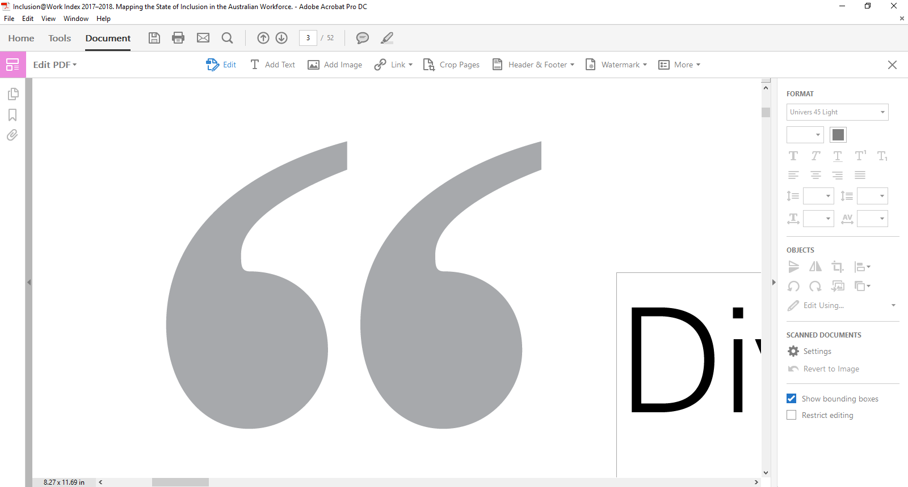

Gender inequality in unpaid care has been described by the OECD as the missing link in understanding gender gaps in labour outcomes.[20]

|  |
| --- |
| We need to:  **Recognise** unpaid care and work by measuring it  **Reduce** the burden of unpaid care and work through investments in physical and social infrastructure  **Redistribute** the work through policies that encourage men to take up more care work. |

Source: Diane Elson (2017), ‘Recognize, Reduce and Redistribute Unpaid Care Work: How to Close the Gender Gap’, New Labor Forum, 26(2): 52-61.

There is a high level of support for sharing the care amongst Australians – Australian men and women overwhelmingly believe (90 per cent) that men should be as involved in parenting as women. However, while a significant number of fathers, and in particular young fathers, would like to be able to access better workplace flexibility arrangements, men are much more likely than women to have such requests denied.[21]

Many strategies can reduce the burden of unpaid work including increasing public and care services and introducing workplace policies that are supportive of families, challenging gender stereotypes and social norms that reinforce traditional gender roles, and implementing fiscal policies that recognise the potential disincentives for female labour force participation.

However, in this report DCA decided to pick one key action government, employers, and families could each take to enable Australians to better share the care between men and women and so close the gender pay gap.

What government can do:

The top five OECD countries, with the highest percentage of working mothers, have national child care programs (Iceland, Slovenia, Denmark, Sweden and the Netherlands).22

Ensure affordable, available, flexible and accessible universal child care. Universal access ensures that all families can access quality child care, in a form that meets the needs of children, parents and community, and at a cost that does not present a barrier to participation. Research indicates that where affordable, quality child care is available, women are more likely to work, stay employed and hold better jobs, all of which contribute to narrowing the gender wage gap.[22]

What employers can do:

Telstra’s [*All Roles Flex*](https://careers.telstra.com/allrolesflex) initiative effectively makes flexibility the starting point for all Telstra jobs rather than a special accommodation or allowance. Here flexibility in some form can be available for all positions, including store-based, customer-facing roles. Workers express preferences for particular shifts, non-traditional working hours, working at other locations and considering job-sharing and part-time work with no reasonable requests for flexible work refused.

Make sure flexible work is available to anyone for any reason, and introduce ‘shared care’ parental leave so all parents have equal paid leave and can access this flexibly.

Evidence from Sweden indicates that fathers’ use of parental leave has direct positive impacts on their partner’s earnings – with an uplift of 6.7 per cent in earnings of a partner for each month a father stays on leave.[23]

What individuals can do:

Aurizon’s innovative [*Shared Care*](https://www.aurizon.com.au/careers/diversity)parental leave scheme aims to incentivise men to take on primary care of their child in the first year after birth or adoption. It provides a financial incentive based on ‘half-pay’ for a partner to take a leave of absence to stay at home and care for their child in their first year, allowing the mother to return to work full-time. This not only allows men to take on the primary care of their child it also reduces the impacts of unpaid parental leave and part-time employment on its female staff.

Renegotiate in their home who does what when it comes to caring and household management so this is shared equitably and women and men have equal opportunity to work, stay employed and hold better jobs.

|  |  |
| --- | --- |
|  | **What’s Next?** |
| KPMG is working with DCA and WGEA to update and expand the 2016 report, *She’s Price(d)less – The economics of the gender pay gap*. This work will be released in the coming months. | |

1. DCA notes that this report considers ‘care’ primarily as it relates to heterosexual couple families, and that this is not inclusive of all families including in particular same sex and single parent families. Future DCA initiatives will consider the pay gap and caring from this broader perspective.
2. World Economic Forum, *The Global Gender Gap Report*, WE Forum,2018.
3. The gender pay gap is the difference between women’s and men’s average full-time equivalent earnings, as a percentage of men’s earnings based on ABS data. Workplace Gender Equality Agency, *Australia’s Gender Pay Gap Statistics,* 22 February 2019.
4. Workplace Gender Equality Agency, *Australia’s Gender Pay Gap Statistics,* 22 February 2019.
5. J. Hammond, *Australian Attitudes to Pay Equity*: *Report Prepared for Diversity Council Australia,* Auspoll Campaign, 2010.
6. M. Evans, V. Haussegger, M. Halupka, and P. Rowe, *From Girls to Men: Social Attitudes to Gender Equality in Australia,* 50|50 by 2030 Foundation, Canberra, 2019.
7. Ibid.
8. R. Wilkins and I. Lass, *The Household, Income and Labour Dynamics in Australia Survey: Selected Findings from Waves 1 to 16*, Melbourne Institute: Applied Economic & Social Research, University of Melbourne, Melbourne, 2018.
9. Australian women took almost all (95 per cent) of the primary parental leave used by non-public sector employees while 95 per cent of secondary parental leave was taken by men. Australian Bureau of Statistics, *One in 20 Dads Take Primary Parental Leave*, Gender Indicators 4125.0*,* 19 September 2017. Accessed 19 February 2019 at <https://www.abs.gov.au/ausstats/abs@.nsf/Lookup/by%20Subject/4125.0~Sep%202017~Media%20Release~One%20in%2020%20dads%20take%20primary%20parental%20leave%20(Media%20Release)~11>.
10. KPMG, *She’s Price(d)less: The Economics of the Gender Pay Gap,* KPMG, Sydney, 2016.
11. R. Wilkins and I. Lass, *The Household, Income and Labour Dynamics in Australia Survey: Selected Findings from Waves 1 to 16*.
12. Ibid.
13. Australian Council for Trade Council, *The Gender Pay Gap over the Lifecycle*, ATCU, Melbourne, 2016.
14. Australian Bureau of Statistics, *Difference Between Men and Women,* Gender Indicators 4125.0, September 2018. Accessed 19 February 2019 at <https://www.abs.gov.au/ausstats/abs@.nsf/Lookup/by%20Subject/4125.0~Sep%202018~Main%20Features~Selected%20Highlights~2>.
15. G. Ferrant, L.M. Pesando, and K. Nowacka, *Unpaid Care Work: The Missing Link in the Analysis of Gender Gaps in Labour Outcomes*, OECD Development Centre, 2014.
16. J. Hammond, *Australian Attitudes to Pay Equity*: *Report Prepared for Diversity Council Australia*.
17. KPMG, *The Cost of Coming Back: Achieving a Better Deal for Working Mothers*, 2018. Accessed 19 February 2019 at <https://home.kpmg/au/en/home/insights/2018/10/working-mothers-returning-to-work.html>.
18. G. Ferrant, L.M. Pesando, and K. Nowacka, *Unpaid Care Work: The Missing Link in the Analysis of Gender Gaps in Labour Outcomes*.
19. Norwegian Labour and Welfare Administration NAV, *Parental Benefit*, 2016, cited in Workplace Gender Equality Agency, *Towards Gender Balanced Parental Leave: Australian and International Trends Insight Paper*, WGEA, Sydney, p. 12.
20. G. Ferrant, L.M. Pesando, and K. Nowacka, *Unpaid Care Work: The Missing Link in the Analysis of Gender Gaps in Labour Outcomes*.
21. Australian Human Rights Commission, *Face the Facts: Gender Equality,* AHRC, Sydney, 2018.
22. OECD Social Expenditure Database, *Public Spending on Child Care and Early Education*, 2012, cited in Ontario Gender Wage Gap Strategy Steering Committee, *Final Report and Recommendations of the Gender Wage Gap Strategy Steering Committee: Prepared for Minister of Labour Minister Responsible for Women’s Issues*, p. 23.
23. E.A. Johansson, *The Effect of Own and Spousal Parental Leave on Earnings,* IFAU Working Paper, Institute for Labour Market Policy Evaluation, Uppsala, 2010.