The Case for Class Inclusion at Work

Research shows a strong case for creating class-diverse and inclusive workplaces – for both employees and for organisations.

# Class inclusion is better for employees

Class marginalised employees[1] who work in inclusive organisations[2] are:

* **9.5 times more likely** to be **very satisfied with their job** than class marginalised employees in non-inclusive organisations[3]
* **6.5 times more likely** to feel work has a **positive impact on their mental health**
* **2.5 times more likely** to have **participated in career development opportunities**

Figure 1: Impact of Inclusive Organisation on Class Marginalised Employee Wellbeing

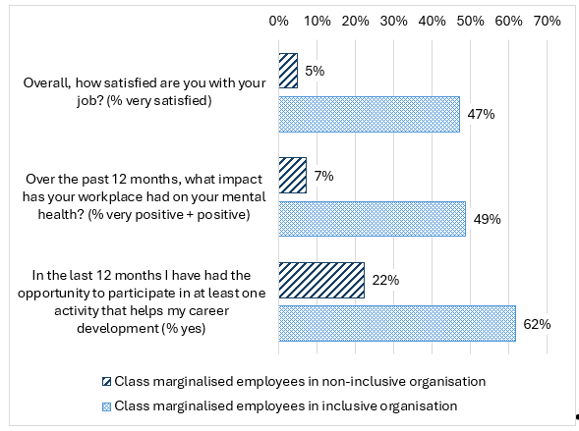

Table 1: Impact of Inclusive Organisation on Class Marginalised Employee Wellbeing

| **Question** | **Class marginalised employees in non-inclusive organisation** | **Class marginalised employees in inclusive organisation** |
| --- | --- | --- |
| Overall, how satisfied are you with your job? (% very satisfied) | 5% | 47% |
| Over the past 12 months, what impact has your workplace had on your mental health? (% very positive + positive) | 7% | 49% |
| In the last 12 months I have had the opportunity to participate in at least one activity that helps my career development (% yes) | 22% | 62% |

# Class inclusion is better for businesses

Class marginalised employees who work in inclusive organisations are:

* **23 times more likely** to report that their team is always **innovative,** compared toclass marginalised employees in non-inclusive organisations
* **5.5 times more likely** to report their team always **works effectively together**
* **4 times more likely** to feel their team always **provides excellent customer service**
* **3 times more likely** to **stay with their current employer**

Figure 2: Impact of Inclusive Organisation on Class Marginalised Employee Performance

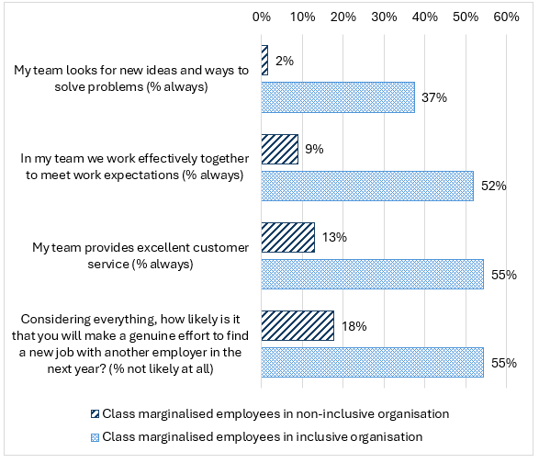

Table 2: Impact of Inclusive Organisation on Class Marginalised Employee Performance

| **Question** | **Class marginalised employees in non-inclusive organisation** | **Class marginalised employees in inclusive organisation** |
| --- | --- | --- |
| My team looks for new ideas and ways to solve problems (% always) | 2% | 37% |
| In my team we work effectively together to meet work expectations (% always) | 9% | 52% |
| My team provides excellent customer service (% always) | 13% | 55% |
| Considering everything, how likely is it that you will make a genuine effort to find a new job with another employer in the next year? (% not likely at all) | 18% | 55% |

1. We have reported on class marginalised employees because our research shows they are much less likely to work in inclusive environments than middle class or class privileged employees. However, the pattern that greater inclusion benefits both employees and business also holds true for middle class and class privileged workers.
2. Inclusive Organisational Climate = Respondents scored their organisation on average 4 or above out of 5 (where 5 = highly inclusive, 3 = neither inclusive nor non-inclusive, 1 = not inclusive at all).
3. Findings are drawn from DCA’s 2025-2026 Inclusion@Work Index.