# **Exporting data for your Inclusive Employer 2025-2026 Assessment**

## Why do I need to export?

DCA does not have access to your dashboard or any data captured on it. Due to this, we require you to export a report of select data from your dashboard.

The data is used to do your Inclusive Employer 2025-2026 assessment. Without sending the data, DCA will not be able to assess you as an Inclusive Employer 2025-2026.

## What is in the report sent to DCA?

The report contains information required for the Inclusive Employer assessment. Data is not linked to any of your individual staff members, and the report does not contain any information on the 9 demographic splits from the dashboard. For example, we will not receive data on how your staff with caring responsibilities answered compared to your staff without caring responsibilities, etc.

DCA has strict data security and protection around the use and storage of emails and files. The report you send us will be assigned a code to replace your organisation’s name, and will be password-encrypted in our storage system. Please let us know if you would like more information on this.

## When do I export?

You can send the required export once you have finished your survey collection period (i.e. when you are no longer collecting survey responses from your employees).

## How do I export?

Once logged into your dashboard, from any page:

Step 1: If you have created multiple groups (e.g. you sent different links to employees based on department) make sure you send this report from the “View As” page of your organisation as one group (i.e. the page showing your groups merged). If you did not create groups, start at Step 2.

Step 2: Go to the top right corner of the page and select the blue “Export” button.

Step 3: Select “Send report” from the “DCA Report” option (see below). Once selected, the report will automatically be sent to DCA. A confirmation message may not show immediately, so after sending “Send report” once, “Close” out of the window and wait for a green confirmation message.

## Demonstration of Step 2

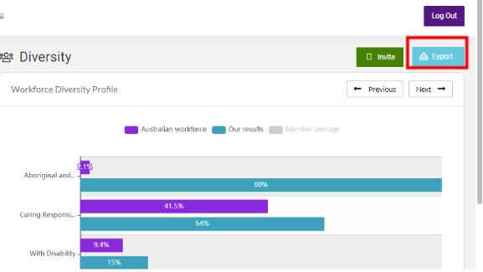

## Demonstration of Step 3

A screenshot of the Export menu with three options. 1. Administrator report
2. DCA report 3. WGEA EOCGE data report. DCA report has a red rectangle around it.