DCA’s 2026-2027
Inclusive Employer Index

Information Booklet

Is your organisation as inclusive as you think? Are you unsure where you should focus your diversity and inclusion (D&I) efforts? Would you like to assess and benchmark the state of inclusion in your workplace?
We invite your organisation to participate in this year’s Inclusive Employer Index to measure diversity and inclusion in your workplace.

Benefits of participating

Diagnostic benefits
By taking part in the Index, you will have the opportunity to measure diversity and inclusion in your workforce, understand the impact of inclusion, and take a data-driven approach in determining where to focus your D&I efforts.
Specifically, you will access data points for the:
- diversity of your workforce across a number of measures
- workplace inclusion and exclusion experiences of your employees, including across different demographics
- impact of workplace inclusion on team and employee outcomes
- 5 survey questions required for any organisation applying for the Workplace Gender Equality Agency’s Employer of Choice for Gender Equality (or Employer Committed to Gender Equality) citation.
Participation also includes access to benchmarks to compare your diversity and inclusion results with a DCA Member Benchmark, and an Australian Workforce Benchmark, derived from a nationally representative survey of 3000 workers in Australia.

Branding benefits: Profiling as an Inclusive Employer 2026-2027
Organisations that participate in the Inclusive Employer Index are eligible to be assessed as an Inclusive Employer 2026-2027. Organisations deemed Inclusive Employers will be publicly promoted by DCA on its website and able to use associated communications and materials (e.g. email signature logos, social media tiles, etc.). See our list of current and past Inclusive Employers.

Can we participate if we are just starting on our Diversity & Inclusion journey?
The Inclusive Employer Index is designed to be a diagnostic tool for organisations to map, track and take action on, no matter where they are in their D&I journey.

Survey content

What do the Index survey questions cover?
The survey has been developed and refined over 6 iterations in consultation with an expert panel of practitioners and academics, and covers three broad areas:
- Experience of workplace inclusion and exclusion: including inclusion within an immediate team, with managers, and within the inclusive organisational climate, as well as inclusive behaviours, exclusionary behaviours, and employee awareness and support of organisational D&I activity.
- Diversity: including Aboriginal and/or Torres Strait Islander background, age, caring responsibilities, country of birth, cultural background, disability status, gender identity, multilingual ability, religious affiliation, and sexual orientation.
- Impact of inclusion: across team effectiveness, innovation, customer service, discretionary effort, job satisfaction, and turnover intentions. The results of these questions are used to build a business case for D&I in your organisation.

Can we access a copy of the full survey?
For intellectual property reasons, DCA is not able to share the full survey. However, DCA members can get a feel for the type of questions asked from our Inclusion@Work research series that uses the same survey questions.

Survey findings/results

What findings will my organisation receive?
Your organisation can explore your results in 3 ways:
- Online interactive dashboard: DCA is partnered with Cultural Infusion to enable participating organisations to explore their findings interactively in an interactive dashboard. The dashboard displays results across three main sections:
- Diversity metrics: a summary of your diversity data, benchmarked against the Australian Workforce and DCA Member benchmark
- Compare metrics: displays how your employees responded to the inclusion and exclusion questions, and the impact of inclusion questions compared against the Australian Workforce and DCA Member Benchmarks.
- Inclusion and exclusion experiences x diversity metrics: displays how your employees responded to the inclusion and exclusion questions across up to 9 diversity dimensions (i.e., Aboriginal and/or Torres Strait Islander background, age,
continued
caring status, cultural background, disability status, gender, language, LGBTIQ+ status, and religious affiliation). For example, how your employees with caring responsibilities answered compared to those without caring responsibilities.
Online dashboard findings can be accessed in the Online Interactive Dashboard until 31 December 2026.
- PDF Report. A brief review of some of your organisation’s results, including:
- Your diversity profile compared to the Australian workforce and DCA Members
- Aggregated scores for team inclusion, inclusive managers, and inclusive organisation, compared to the Australian workforce and DCA Members
- An individualised business case for inclusion in your organisation, showing the impact of inclusion on your employee performance and wellbeing.
- Exports. For the period commencing 1 July 2026 to 31 December 2026 that you have access to the dashboard, you can download a selection of online dashboard findings in PDF or CSV form and/or take screen grabs.

When will we receive our findings?
The majority of your results will be available in your online interactive dashboard live – that is, as employees fill in the survey you will begin to see your results.
The PDF report of high-level findings will be available to your organisation within three months of the final close date of the Index survey in your workplace.

What benchmarks are there?
All compare metrics, and many diversity metrics can be benchmarked in up to three ways:
- Australian Workforce Benchmark: based on a nationally representative survey of 3000 workers in Australia.
- DCA Member Benchmark: based on all employees from participating DCA Member organisations who took the survey.
- Industry Benchmark from participating organisations in the same industry. Please note, this is only possible where there are three or more organisations participating in the industry.

Is assistance with interpreting the findings available?
DCA will hold a one-hour online workshop on how to approach reviewing findings, as well as a guide on how to explore your data, to assist you in understanding your data.

Profiling as an Inclusive Employer 2026-2027
Organisations that administer the Inclusive Employer Index, if deemed eligible, are able to show their commitment to diversity and inclusion by displaying the Inclusive Employer 2026-2027 logo.
To be deemed eligible as an Inclusive Employer 2026-2027, participating organisations must have administered the Inclusive Employer Index between 1 July and 30 September 2026, and:
- Invite at least 65% of their employees to participate
- Have a response rate of at least 20% of all survey tokens sent; and
- Show that they are active and committed to inclusion by achieving results that exceed the National Index Benchmark on at least five out of six of the following measures: (i) Awareness for D&I action; (ii) Engagement with D&I action; (iii) Inclusive Organisational Climate; (iv) Inclusive Leadership; (v) Inclusive Team; (vi) Exclusion.

Cost of participation

How much does it cost and who do I pay?
Cost of participation is tier-based, dependent upon whether you are a for-profit or a not-for-profit organisation, and how many staff you plan to invite to participate. Not-for-profit organisations must be currently registered with the Australian Charities and Not-for-profits Commission to be eligible for non-for-profit pricing.
DCA will send you an invoice and it must be paid prior to the fieldwork commencing. Payment upfront will confirm participation. The costs are specified in the following table.
Tier | Member cost - For profit | Member cost - Not-for-profit
45-99 employees | $2,520 + GST | $2,160 + GST
100-499 employees | $4,680 + GST | $3,950 + GST
500-2499 employees | $5,670 + GST | $4,860 + GST
2500-4999 employees | $6,660 + GST | $5,040 + GST
5000-7499 employees | $8,820 + GST | $7,380 + GST
7500-9999 employees | $11,466 + GST | $9,594 + GST
10,000+ employees | Please contact us | Please contact us
Note: The above costs are for DCA Member organisations. If you are not a DCA member, please add 30%.
continued
You must invite at least 65% of your total cohort in order to be eligible for the Inclusive Employer certification. As part of a privacy measure, the dashboard will not show any results unless 36 employees have taken the survey. Due to this, and for data to be meaningful, organisations must have at least 60 employees to participate in the Inclusive Employer Index.
Early bird offer

Members and non-members can sign up early with a 10% discount from 5 March - 5 April 2026. Expressions of interest and payment must be completed by 5:00pm (AEST) on 30 May 2026. Terms and conditions may change at our discretion.

Survey administration

How is the survey sent out?
The survey is already set up and only requires a survey link to be generated. Participating organisations use the interactive dashboard to generate a survey link that is unique to their organisation and have control over how the survey link is shared.
Organisations that experience higher response rates report having a well-planned communications strategy, using a mix of different communications methods (e.g., through emails to employees, in QR codes or posters around office spaces, in intranet systems, or in online team chats, etc.).

How long does the survey take to complete?
The survey takes approximately 14 minutes to complete and is both desktop and mobile optimised.

When will the survey be administered?
Participating organisations can choose any window between 1 July and 30 September 2026 in which to have their Index survey administered. The dashboard to review results is open until 31 December 2026.

Can the survey be sent to our overseas offices?
The survey questions were developed for the Australian workplace and reflect the Australian context. As such, we recommend organisations only run the Index for employees located in Australia. In particular, the demographic questions are reflective of the Australian context (e.g., the question on cultural background is difficult to use outside of Australia) and may not be accurate or applicable for employees located in overseas offices.

Can I change the wording of the questions, or change any of the answers offered?
The survey is standardised to allow for benchmarking, meaning questions are not able to be changed or adapted. However, if you believe there is an error in either, please contact DCA.

What are ‘groups’ and should we use them?
The dashboard has an in-built function to allow participating organisations the ability to explore findings by different levels (e.g., employees in different business areas, departments, divisions). The decision as to whether or not to have groups is up to you - there is no right or wrong. Some organisations create groups by region (e.g., VIC, NSW, etc.), some by Business Unit (e.g., IT, HR, Marketing, etc.), some by function (e.g., Legal, Non-legal) and some by level (e.g., Executive, Management, General Staff, etc.).
Some organisations do not create groups at all, preferring a ‘one-for-all’ approach.
As creating groups allows you to isolate data that are group-specific, it means a lot more data to analyse but it also means more nuanced analysis is possible. As results cannot be isolated until the threshold of 36 responses is reached, our recommendation is to not create groups with less than 80 employees.

Confidentiality and security

Will other participating organisations receive information about how my organisation has performed?
No other participating organisation will receive any information about how your individual organisation performed. Any comparison data that is provided (for example, data from your industry sector) will be fully aggregated and de-identified. DCA will not publish individual organisation results, only aggregated results.

Our IT people are asking questions. What do I tell them?
- Cultural Infusion is ISO270001 Certified.
- The survey is stored at the AWS cloud (Sydney).
- The data does not sit on Cultural Infusion, DCA or customer servers.
- The customer owns the data.
- All data is encrypted in transit and at rest.
- Data can be wiped upon request.
- The platform is compliant with Australian Privacy Laws (and GDPR laws).
The site that must be on their allow-list is: http://au.dca.culturalinfusion.com/
For many customers, the above information is enough to keep IT happy, however if they require further information, please contact your DCA Member Engagement Team (see contact details on following page).

Who owns the data?
As the customer, you own your data. The survey is conducted online via a link sent to your organisation’s employees (set up by you), hosted, and managed by the Cultural Infusion platform. All data is stored on the AWS cloud (Sydney) and does not reside on either Cultural Infusion, DCA or customer servers. Cultural Infusion and DCA do not have access to your staff contact details.

What are our next steps to participate?
Intention to register should be communicated to Memberservices@dca.org.au. The team will need to know the size of your cohort and your invoicing details, including correct organisation name, postal address, phone number and relevant contacts. Once established, DCA will forward an invoice.
Once the invoice is paid, the next steps can be taken to participate.

Appendix: DCA definitions of Diversity and Inclusion

Diversity
Diversity refers to all the differences between people in how they identify in relation to their social identity (that is, their Aboriginal and/or Torres Strait Islander background, age, caring responsibilities, cultural background, disability, gender, LGBTIQ+ status, and socio-economic background), and their professional Identity (that is, their profession, education, work experiences, and organisational role).

Inclusion
Inclusion is getting this mix to work – creating an environment where a diversity of people are respected, connected, and progressing and contributing to their organisation’s success.
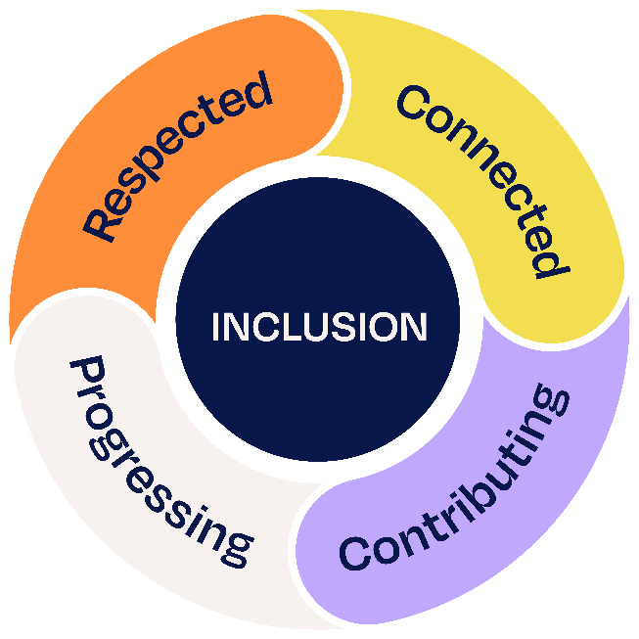
Inclusion occurs when a diversity of people (i.e. from different ages, gender etc.) feel that they are:
- Respected. Inclusion occurs when a diversity of people at work feel valued and respected for who they are.
- Connected. Inclusion occurs when a diversity of people feel connected to their co-workers, treated as an insider, and so have a sense of belonging.
- Progressing. Inclusion occurs when a diversity of people at work have opportunities to develop their career, and
- Contributing. Inclusion occurs when a diversity of people can contribute their talents and energies to the organisation.

